Sem 1 Examination 2015


Question/answer booklet

MATHEMATICS
Please place your student identification label in this box
SPECIALIST

Section One:
Calculator-Free
Name:

Teacher:

Time allowed for this section
Section One
Reading time before commencing work: 5 minutes
Working time for paper: 50 minutes

Material required/recommended for this paper

To be provided by the supervisor
This question/answer Booklet
Formula sheet

To be provided by the candidate
Standard items: pens, pencils, pencil sharpener, eraser, correction fluid/tape, ruler, highlighter

Special items: drawing instruments, templates, notes on two unfolded sheets of A4 paper, and up to three calculators satisfying the conditions set by the Curriculum Council for this course.

Important note to candidates
No other items may be taken into the examination room. It is your responsibility to ensure that you do not have any unauthorised notes or other items of a non-personal nature in the examination room. If you have any unauthorised material with you, hand it to the supervisor before reading any further.

To be provided by the supervisor
Question/answer booklet for Section One, containing a removable formula sheet which may also be used for Section Two.

Structure of this examination
Papers written by
Australian Maths Software

 | Number of questions available | Number of questions to be answered | Working time (minutes) | Marks available | Percentage of exam
Section One  Calculator—free | 7 | 7 | 50 | 50 | 35
Section Two  Calculator—assumed | 10 | 10 | 100 | 100 | 65
Total marks |  |  |  | 150 | 100

Instructions to candidates

1. The rules for the conduct of this examination are detailed in the Information Handbook.
Sitting this examination implies that you agree to abide by these rules.

2. Write your answer in the Question/Answer booklet.

3. You must be careful to confine your responses to the specific questions asked and to
follow any instructions that are specific to a particular question.

4. Spare pages are provided at the end of this booklet. If you need to use them, indicate
in the original answer space where the answer is continued i.e. give the page number.

5. Show all your working clearly. Your working should be in sufficient detail to allow your
answers to be checked readily and for marks to be awarded for reasoning. Incorrect
answers given without supporting reasoning cannot be allocated any marks. For any
question or part question worth more than two marks, valid working or justification is
required to receive full marks. If you repeat an answer to any question, ensure that you
cancel the answer you do not wish to have marked.

6. It is recommended that you do not use pencil, except in diagrams.

7. The Formula Sheet is not to be handed in with your Question/Answer booklet.

1. (8 marks)

Given a = 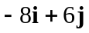and b = 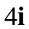 find

(a) 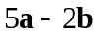 (1)

(b) 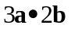 (1)

(c) 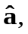 the unit vector in the direction of . (2)

(d) Find the scalar projection of a on b. (2)

(e) a vector v, such that v is in the direction of 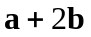and has a magnitude of 3. (2)

2. (6 marks)

(a) What is the minimum number of people that need to be selected to ensure there are at least two that were born on the same day of the week? Explain. (2)

(b) Show that 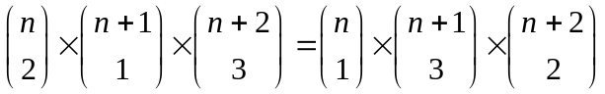 (4)

3. (8 marks)

Consider the statement
“I am human, therefore I eat.”

(a) Write down the converse of the statement. (2)

(b) Is the converse valid? Explain. (2)

(c) Write down the contrapositive of the statement. (2)

(d) Is the contrapositive valid? Explain. (2)

4. (11 marks)

(a) Provide a counterexample to each of the following
(i) If a quadrilateral has diagonals that bisect at right angles, then it is a
square. (2)

(ii) If 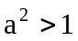then 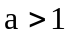 (2)

(iii) If and only if an animal is an elephant, then it has big ears. (2)

(b) Determine whether or not 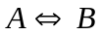
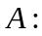 The quadrilateral has four equal sides.
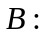 The quadrilateral is a square. (2)

(c) Rewrite the following mathematical statement in words:
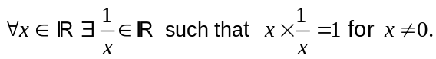 (3)

5. (6 marks)

Use the diagram below to prove by contradiction that
“The sum of the angles in a triangle add to 180⁰ ”. (6)

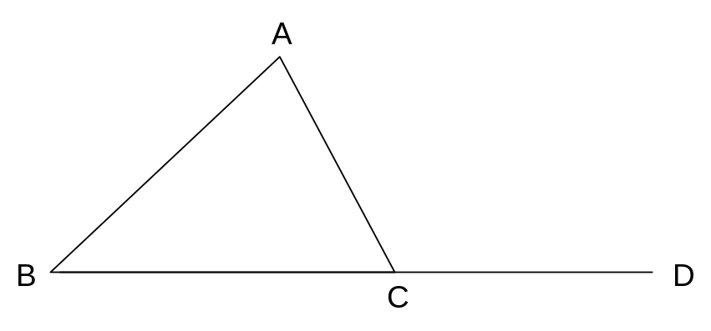
6. (6 marks)

Use a vector method to prove
"The sums of the squares of the lengths of the diagonals of a parallelogram is equal to the sum of the squares of the lengths of the sides.”
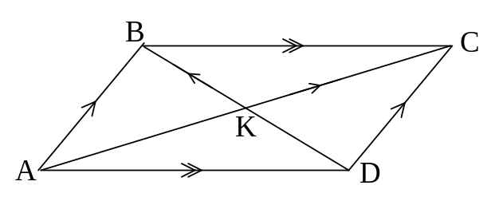
Hint: Let 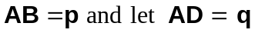 (6)

7. (5 marks)

Use a vector proof to prove that
“If the midpoints of a quadrilateral are joined, the resulting quadrilateral is a
parallelogram.”

Use the diagram below: (5)
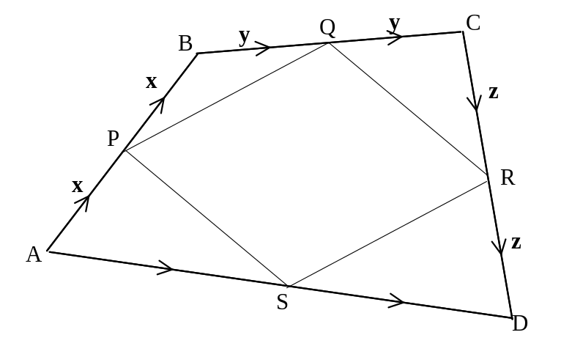

END OF SECTION ONE
Extra page for working if necessary

